 | [Insert School’s own header]

Declaration of Originality Form
This form must be completed and signed and submitted with all assignments.
Please complete the information below (using BLOCK CAPITALS).
Name
Student Number
Course Name
Assignment Number/Name
A link to the University’s Plagiarism and Academic Integrity Code is provided at the end of this form. Please read the Plagiarism and Academic Integrity Code carefully THEN read and sign the declaration below.
I confirm that this assignment is my own work and that I have:
Read and understood the guidance on plagiarism in the Student Handbook, including the University of Glasgow Plagiarism and Academic Integrity Code |  | ☐
Read and understood guidance that is available on generative artificial intelligence (AI)  - by the University;  - by the School;  - in relation to this specific piece of assessment |  | ☐
Clearly referenced, in both the text and the bibliography or references, all sources used in the work |  | ☐
Fully referenced (including page numbers) and used quotation marks for all text quoted from books, journals and online sources, in accordance with the School’s accepted referencing style(s). |  | ☐
Provided the sources for all tables, figures, legends, data, and code that are not my own work |  | ☐
Ensured that I have not made use of any of my own work, or the work of any other student(s) past or present without acknowledgement. This includes work that has been previously, or concurrently, submitted for assessment, either at this or any other educational institution, including school. |  | ☐
Not sought or used the paid services of any external agencies, including plagiarism checkers or proofreading services |  | ☐
Not used any website or software that generates assessment content without clearly acknowledging that I have done so |  | ☐
Ensured that if use of generative AI is permitted in this assessment, I have clearly acknowledged its use, citing the specific tool(s) used (e.g. ChatGPT, Copilot, Bard, DeepSeek) and how they were used |  | ☐
In addition, I understand that any false claim in respect of this work will result in conduct action in accordance with University regulations |  | ☐
DECLARATION:
I am aware of and understand the University’s policy on plagiarism and academic integrity and I certify that this assignment is my own work, except where indicated by referencing, and that I have followed the good academic practices noted above
Signed

The University of Glasgow Plagiarism and Academic Integrity Code
The University of Glasgow Plagiarism and Academic Integrity Code can be found in the University Regulations at https://www.gla.ac.uk/myglasgow/apg/policies/uniregs/regulations2025-26/feesandgeneral/studentsupportandconductmatters/reg32/

If you are still unsure or unclear about what plagiarism is or need advice on how to avoid it,
SEEK HELP NOW!
You can contact any one of the following for assistance:
Lecturer
Course Leader
Dissertation Supervisor
Adviser of Studies
Student Learning Development Service
Remember to also read your Course or Programme Handbook for advice on good academic practice.

Declaration of Contribution
Please replace this text when adding your declaration “Declare which what the members of the team have contributed to and whether there was a problem in sharing the task. A member that has not contributed to this work by overriding this statement fairly will lose marks and other members will see their marks upgraded. If there is no apparent problem, then all team members will be awarded the same marks. For this a separate assessment will require you and your team members to assess your own work and peer assess your teammates. The quality of your reflection will also be assessed.”

- Determine the constraints for EID and regulations in relation to LIS (half a page)
This will require accessing government documentation and farm magazines for references to provide you with the necessary background.

- What are the consequences of misidentification of dairy cows in farm environments (half a page)
This will require understanding the underlying reasons why cows need to be identified and hw the identification affects farm operation and individual cows on a daily basis as well as the LIS system and milk buyer information.

- Formulating the idea: Answer the following question about the idea? (Take a photo of the A3 sheet or generated with murals – it needs to be legible)
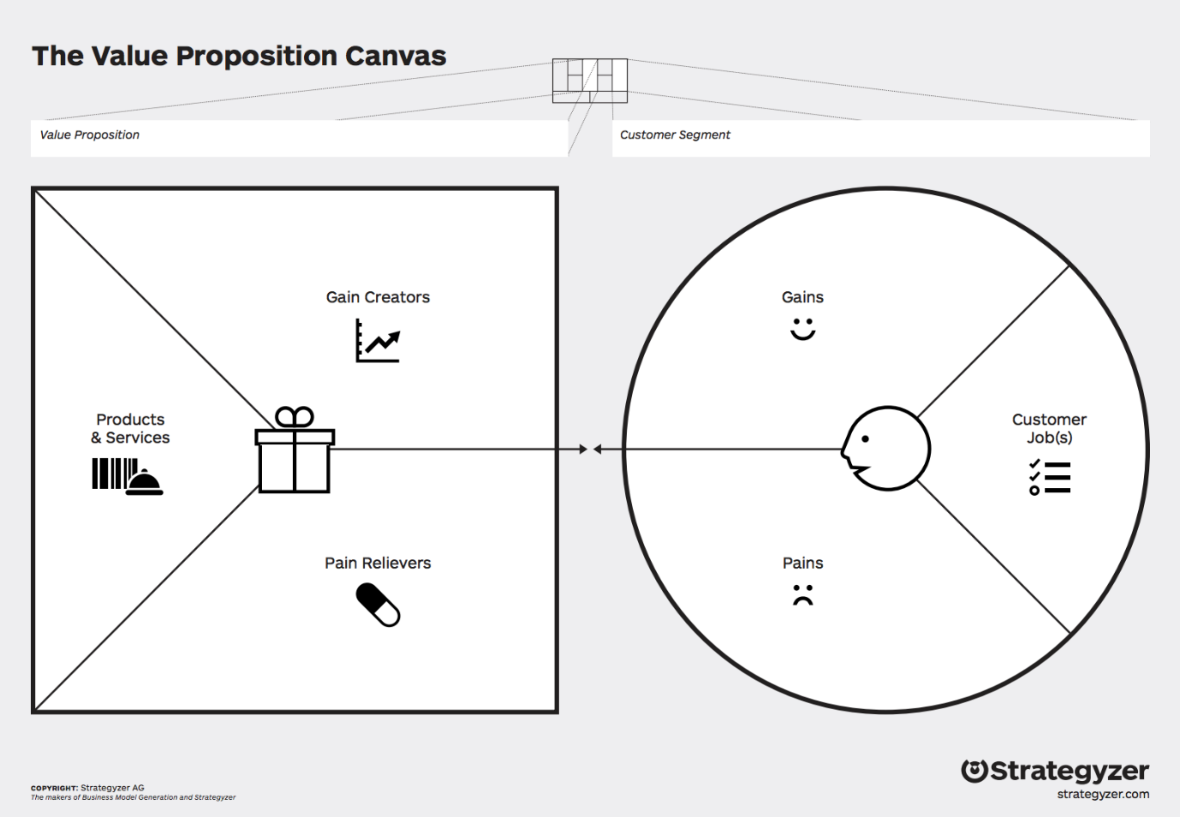

- Identifying group membership and differentiation factors (up to 1 page)
From this analysis, determine the points of parity and the points of difference between your company/product with your selection of competitors one by one.

- More on competition analysis (up to 2 pages)
From this analysis, conduct a porter’s 5 forces, SWOT, PESTEL analysis. Choose at least 2 techniques to analyse the context of your product/service mix. You do not need to show the template diagrams just go through the analysis using the tools. Determine from your analysis what desirable attributes must your product/service mix have to satisfy customers and the differentiation factor from the competition.

- Product/Service Analysis and competition – unique selling point. (1 sentence)
What is the unique selling point of your solution? Based on your analysis what is important to communicate to your customer base?

7
- Fill in the business canvas (A3 sheet or murals generated – it needs to be legible)
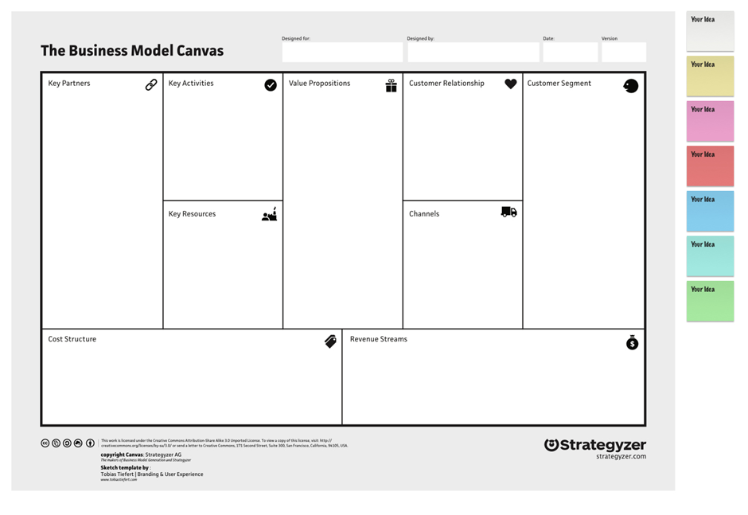
- Critical analysis (up to a page)
How big is your market? What percentage of the market could you reasonably service? Are your desirable attributes aligned with what your customer base wants? Is your product/service mix idea aligned with the customer segment you selected? If not do you need to adjust it? Justify your answers.

- User requirements and justifications (up to 1 page)
Using your product/service mix idea, write down everything your product needs to do. User requirements define what is needed to solve the problem. At this stage, the user requirements outline what the product needs to do, not how the problem will be solved. (up to 10 requirements). Justify the reasoning behind them. This exercise ensures that all user requirements align with solving the problem defined at the beginning. Take each user requirement identified in the previous section, justify why they are needed and help solve the problem. Using the MOSCOW analysis framework insure that all 10 requirements are must have.

- Provide a technical description of the solution e.g. sensor placement, data aggregation, functional block diagram, description of software, interfaces, and pricing to be submitted to your line manager. (up to 4 pages)
Please ensure that it makes sense and the design is logical. If you use flow diagrams or schematics make sure they follow standard practice. Remember also that it should align with what you have proposed as well as the price point for your technology. Furthermore, it should describe everything from the physical structure in which cows go through to the equipment used, circuit, algorithm, and/or machine learning used as well as interfacing with the LIS and the farmers user interface.

- Sustainable development (up to half a page)
Explain how your solution is built for sustainability by discussingyou’re your design aligns with the dairy roadmap https://www.dairyuk.org/wp-content/uploads/2021/11/Dairy-Roadmap-Climate-Ambition-Final-Version.pdf. Provide technical details in line with your design and critically assess the suitability of your design in line with the principles mentioned (do you need to revise your technical description to align your design to the sustainable development roadmap).

- Affordability (up to half a page)
Justify how much your product/service mix will cost for installation and a recurring service fee. Is that in line with the financial means of your customers? Justify your answer.

References (use the IEEE format)
You also need to add a reference section (I would expect an assignment to have between 15-30 references)

